1. Design DFA using simulator to accept even number of c’s over the set {a,b,c}

OUTPUT:

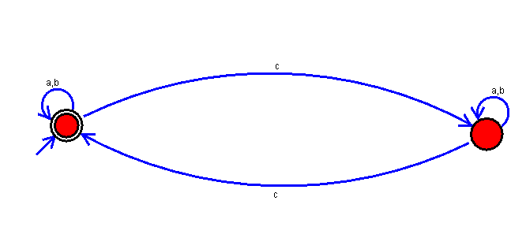

RESULT:The DFA using simulator is accepting even number of c’s over the set {a,b,c}